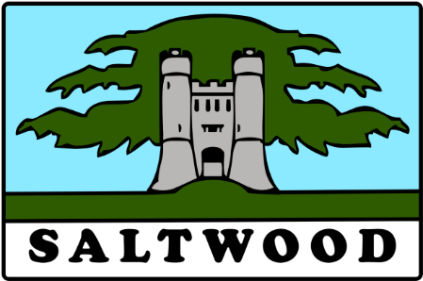

PARISH OF SALTWOOD

NOTICE OF ANNUAL PARISH MEETING

NOTICE IS HEREBY GIVEN THAT
THE ANNUAL PARISH MEETING OF SALTWOOD PARISH WILL BE HELD
ON MONDAY 20TH MAY 2024 AT 7.45 PM AT SALTWOOD C/E SCHOOL

Only such persons registered as local government electors for the Parish will be entitled to vote at the Meeting, but the Meeting will be open to the public during the proceedings, unless the Parish Meeting by resolution otherwise direct

Agenda

1/ Apologies for absence

2/ Minutes of the 2023 Annual Parish Meeting

3/ To receive the Report of the Parish Council for the year ending 31st March 2024

4/ To receive the Report of the KCC Ward Member

5/ To receive the Report of the FHDC Cllrs

6/ To receive Reports from representatives of Village Organisations

7/ To consider any resolutions of which written notice has been given


Geoff Eaton
Clerk to Saltwood Parish Council
Dated 14th May 2 024

